Tables
Table 1: Opportunities for self-employment categorised as retail, service and skill, and manufacture/production
Retail | Service & Skills | Manufacturing/Production
- Spaza shops (selling of. airtime, cigarettes etc.)  - Second hand clothing  - Artwork  - Blankets  - Vendor (at taxi rank, outside school, street pavements etc.)  - Coffee shop | - Freelancing  - Repairs (PC, cell-phone, )  - Administrative duties (Internet café,) Transcriber  - Repairs: WC, Electronics  - Hair salon  - Sowing  - Car wash  - Laundry services  - Driver (Uber)  - IT, photography, web developer, delivery service,  - After school care services  - Domestic work (gardening/maintenance)  - Tukkie wash  - Car wash  - Educating PWDs in se  - Minding (child)  - Manage small security company  - Dog walker  - Tutoring  - Plumbing  - Catering (Cooking)  - Recycling  - Tendering | Hand work e.g.  - Metal work  - Plastic weaved mats  - Baking  - Craft activities (jewellery making, beading, etc.)  - Woodwork  - Toy making  - Carpentry  - Producing and selling a variety of products (e.g., growing and selling vegetables, etc.)  - Dog biscuits
 | - Woodwork, upholstery and shoe repairer and maker

Table 2: This table indicates resources for assessment as suggested by the research participants.
Government | Educational | Private/NPOs/NGOs
- Hospital (OT projects)  - Vocational Rehabilitation Task Team  - Funding: Department of Agriculture, Disabled People South Africa (DPSA), Department of Social Development  - Department of Social Justice  - Skills Education Training Authorities  - Department of Labour  - Women's Development Bank | - Training centres  - Adult Basic Education and Training (ABET)  - In service-training  - Gordon Institute of Business Science (GIBS)  - Technical Vocational Education and Training college | - National Development Agency (NDA)  - Private sector, e.g. job coaching  - Community projects  - Headway Soweto  - Association for People with Disabilities (APD) – for Sheltered employment  - QuadPara Association SA  - Business Incubators  - Media (online Platforms)  - Disability Work Forum  - Mainstream entrepreneur development opportunities  - Work Assessment Units  - Support Groups  - Disability Workshop Development Enterprise (DWDE)  - Peer support

Figures
Figure 1: Level of qualifications of occupational therapists facilitating and not facilitating self-employment in people with disabilities.
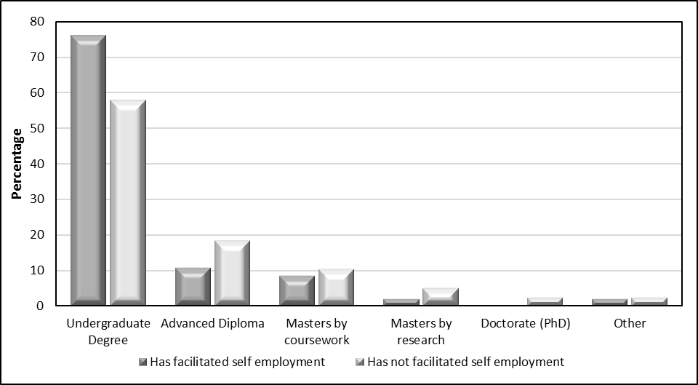

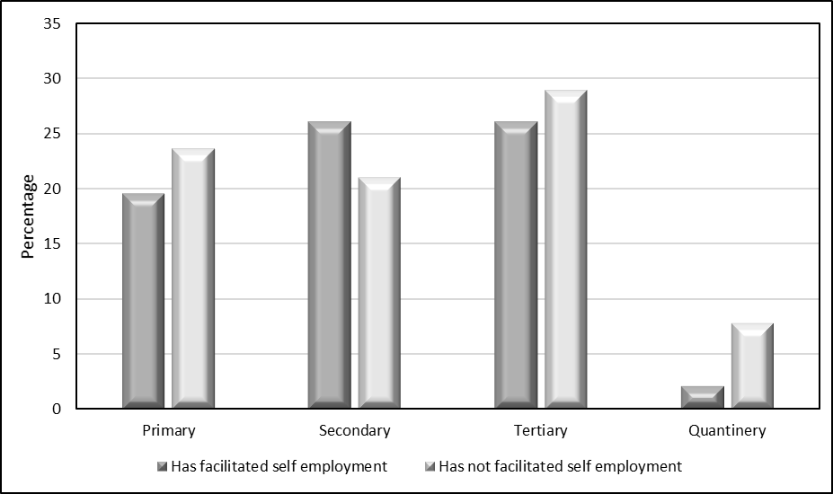
Figure 2: Level of healthcare in which occupational therapists do and do not facilitate self-employment in people with disabilities work.

